**Vpc-task-1: mohammed mujahed-16**

1. Create VPC with 2 private and 2 public subnets.

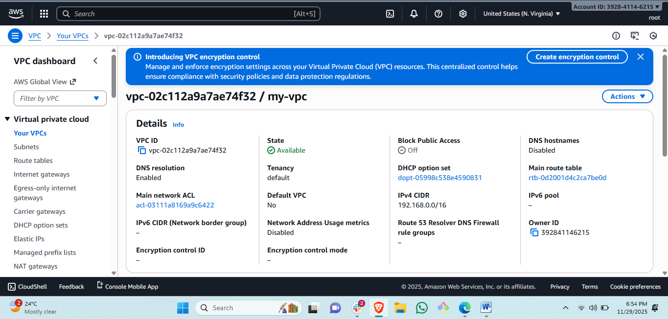

Created vpc: in north verginia region.



Created four subnets :2 public and 2 private:

1. Enable DNS Hostname in VPC.

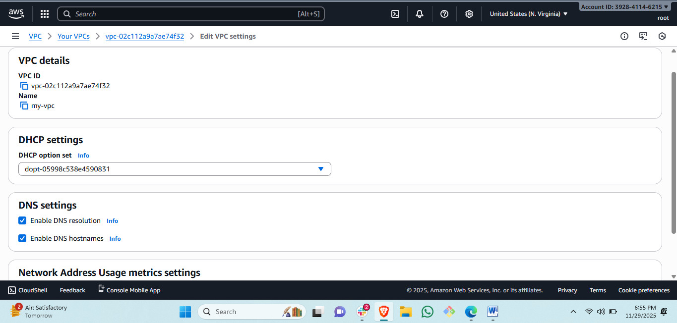

Steps: select the created vpc click on action.

#then click on setting then the right below the LOCAL DNS will disable enable it.

Enabled local dns name.

1. Enable Auto Assign Public IP in 2 public subnets.

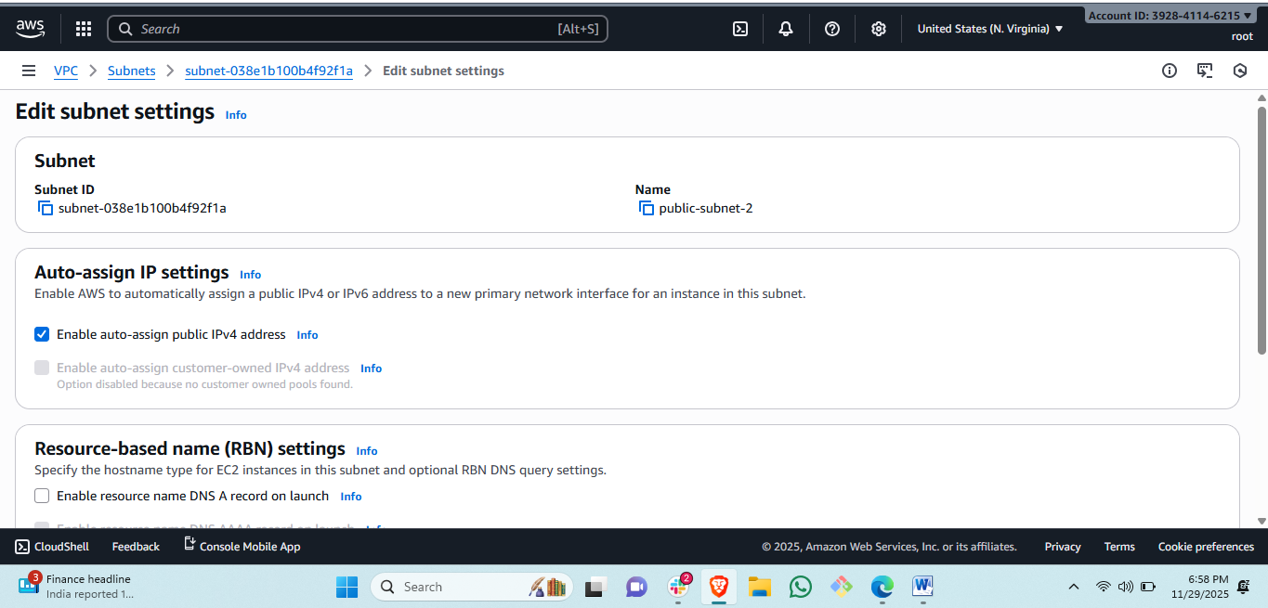

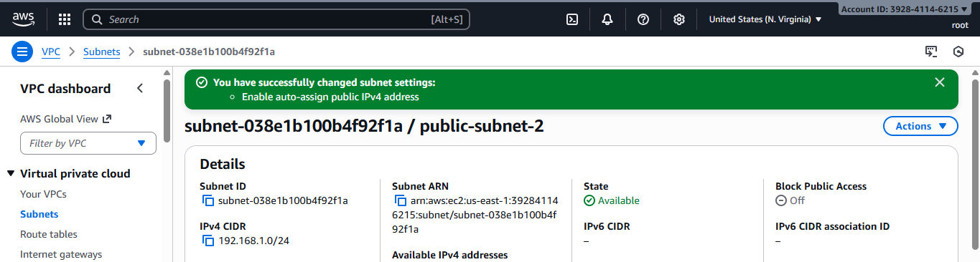

Steps: select the public subnet and click on actions and subnet settings.

#then the auto assign public ip selection box will there select and save it.

1. Add 2 private subnets in private route table.

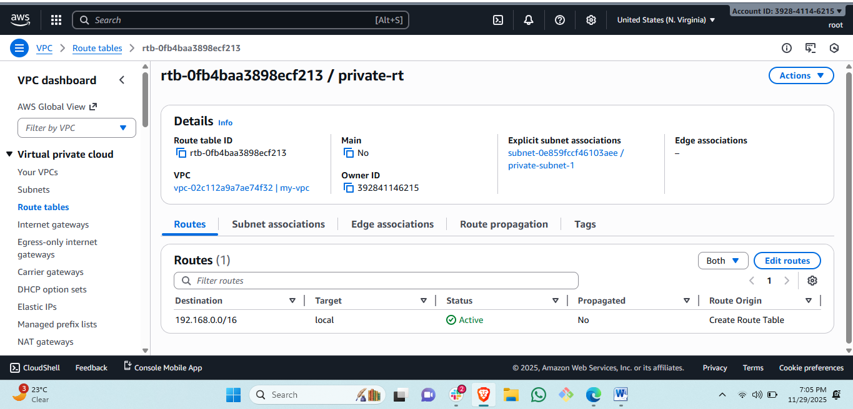

Steps to create route table: go to route table click on create route tableand attach created vpc.



Steps to attach route to subnets: click on private subnet and go to actions and route table accosiation. Attach the created route table.

1. Add 2 public subnets in public route table.

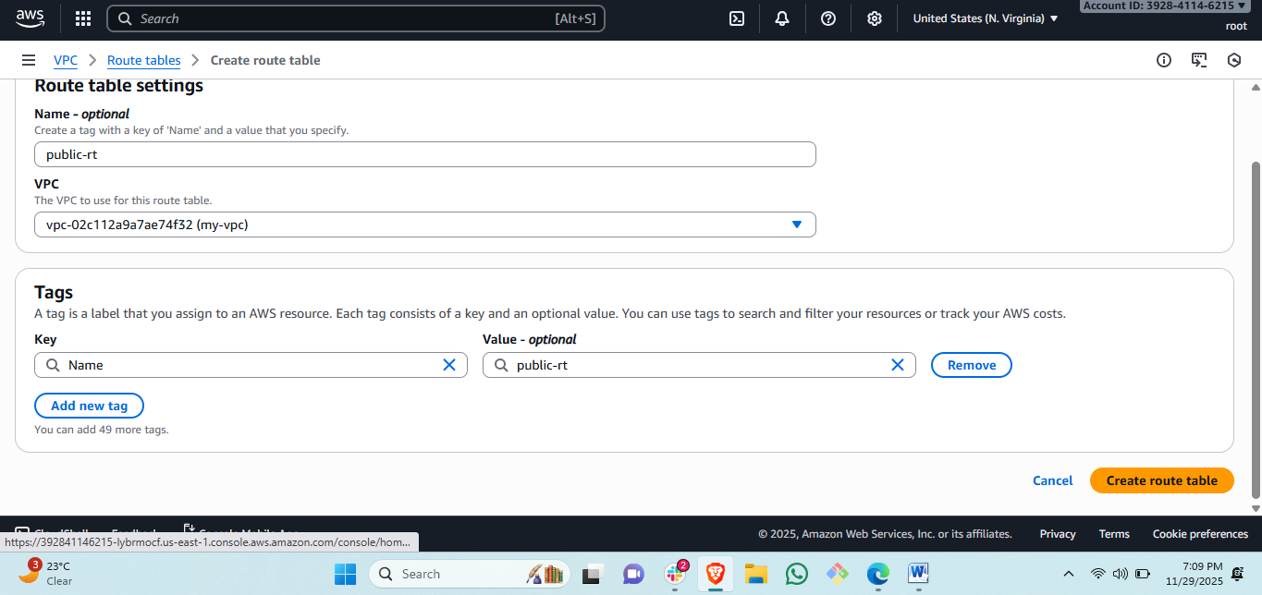

Steps: go to RT and create route and select the created vpc.

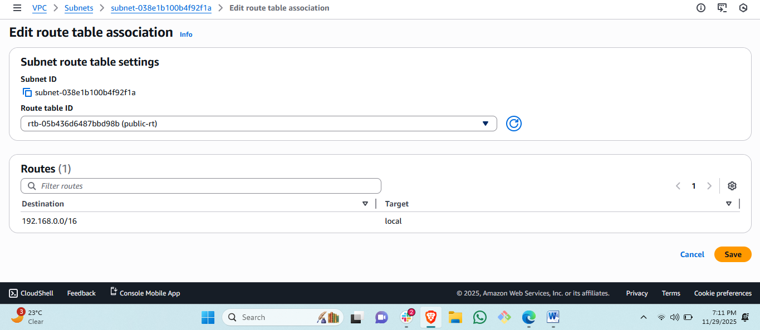

Steps: click on public subnet and click on actions and route table accosiation and attach the public route table to the public subnet.

1. Public route table will have the routes to internet and local.

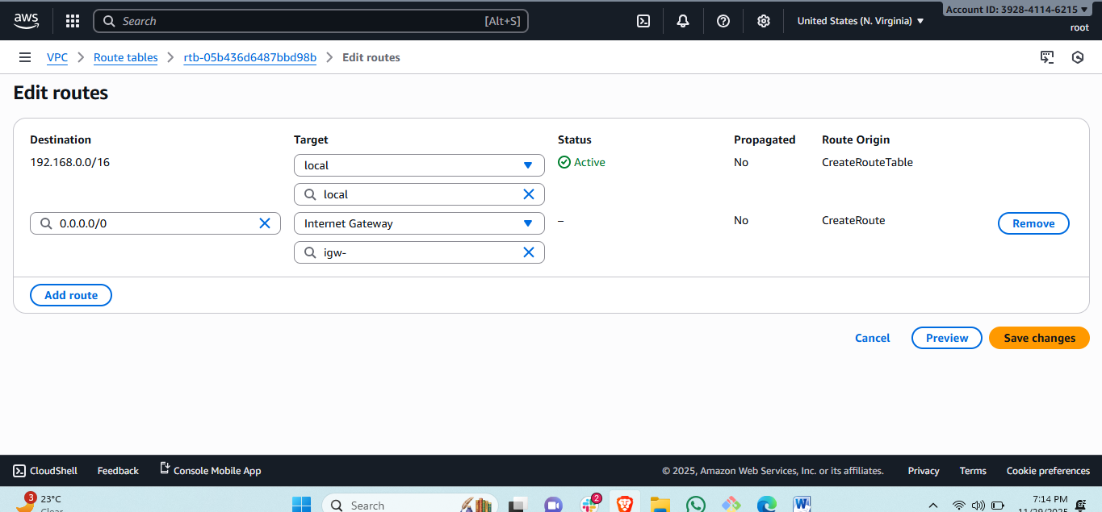

Steps: select the public route table and edit route.  
 #then add 0.0.0.0 protocol and select the internet gatway

1. Create EC2 in public subnet with t2.micro and install PHP.

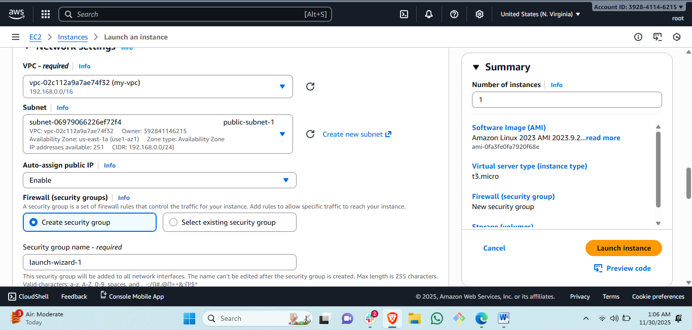

Steps: first launch the instance through amazon ami and select created vpc and pubic subnet and add http and ssh protocol.

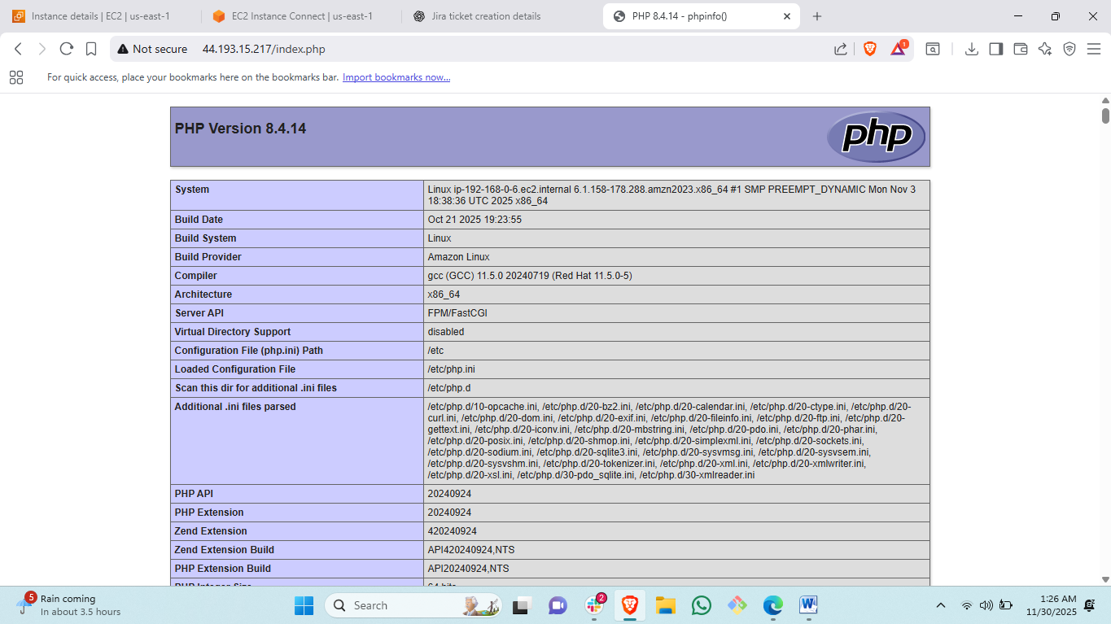

Steps: to configure php file in apache.

sudo yum update -y

sudo amazon-linux-extras install php8.0 -y

sudo yum install httpd -y

sudo systemctl start httpd

sudo systemctl enable httpd

1. Configure NAT gateway in public subnet and connect to private instance.

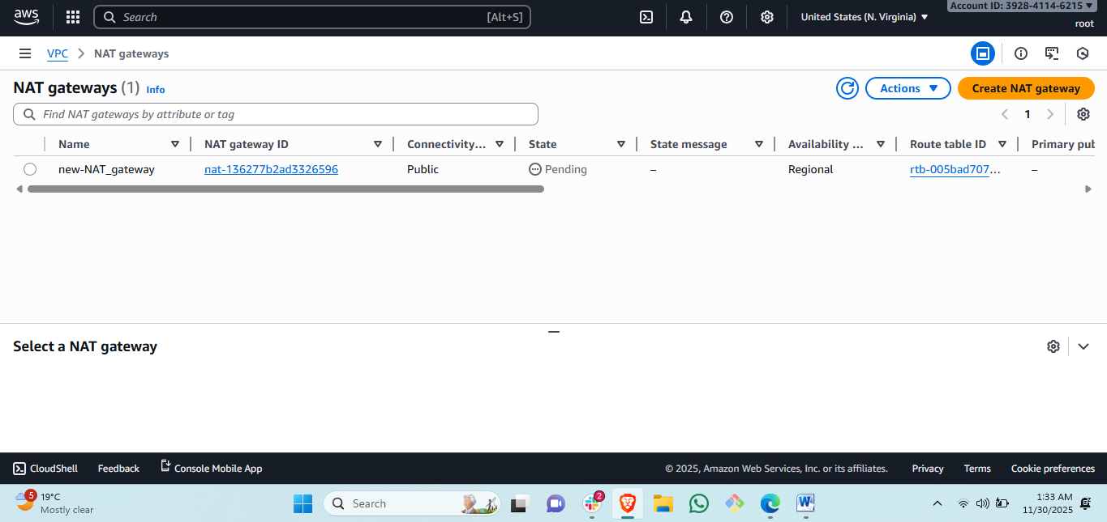

Steps: to create nat gateway click on nat:  
#then create nat gateway add the selected vpc.

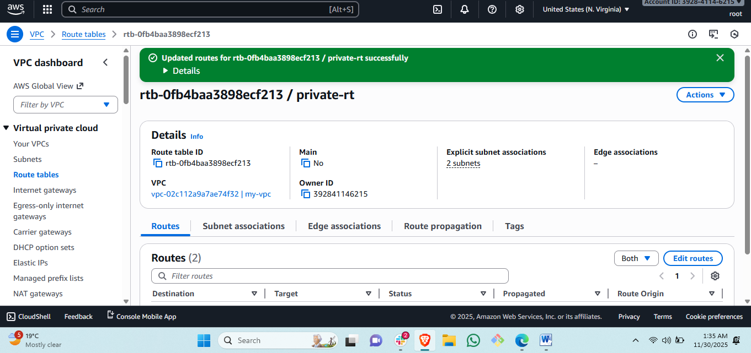

Attach the nat gateway to created private rouying table.

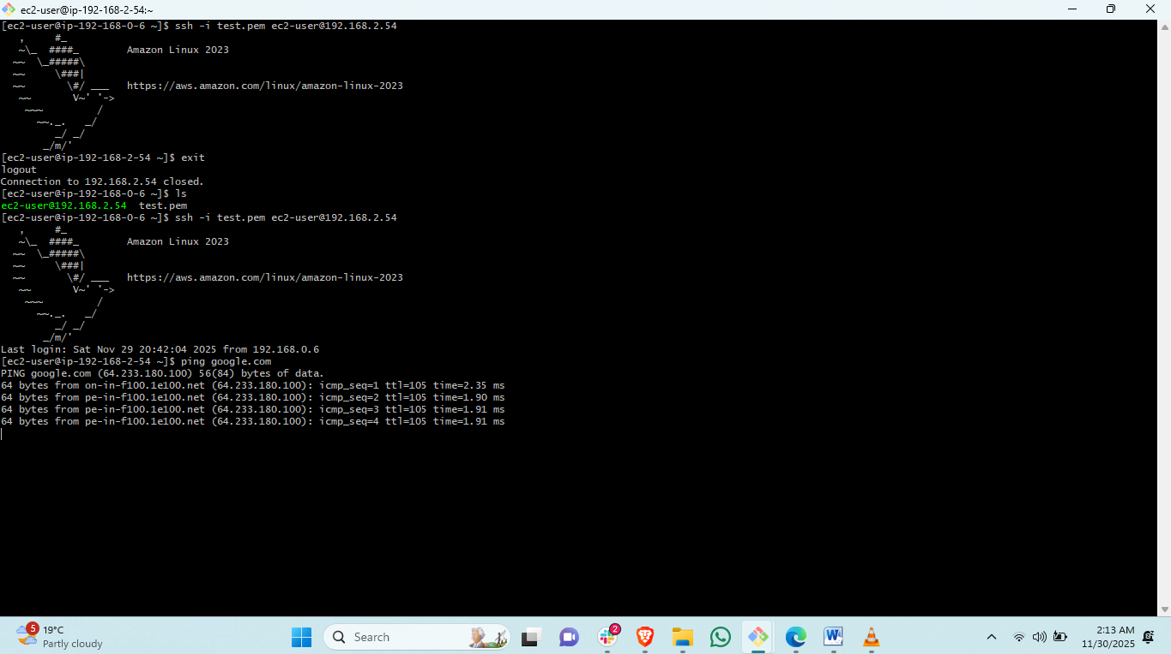

Steps: to verify your

1. Install Apache Tomcat in private EC2 and deploy a sample app.

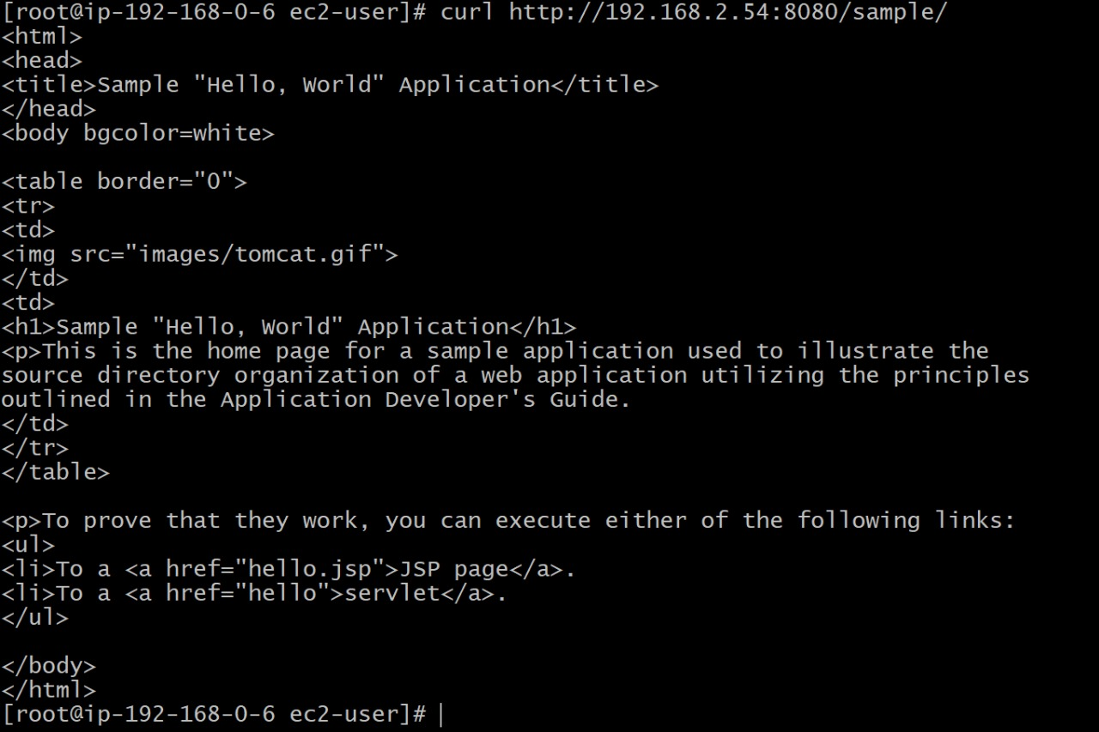

After successfully deploying sapache sapmle app check with this……  
curl <http://private> ip:8080/sample/  
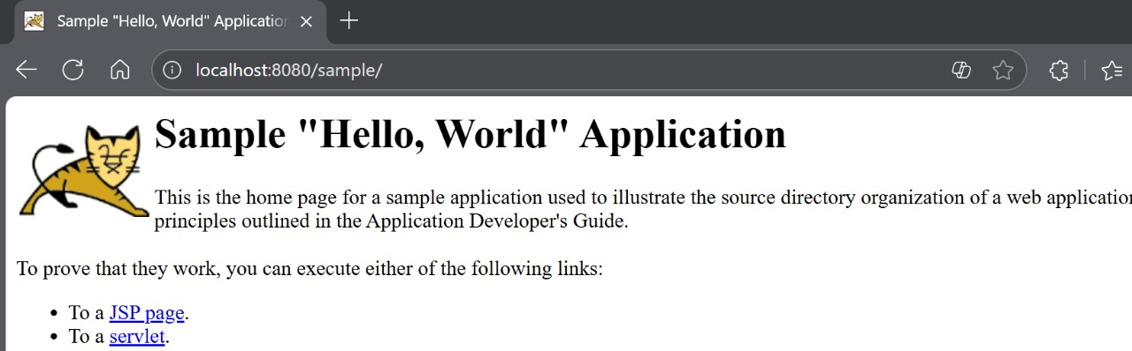  
check from browser by using….localhost:8080/sample/

1. Configure VPC flow logs and store the logs in S3 and CloudWatch.

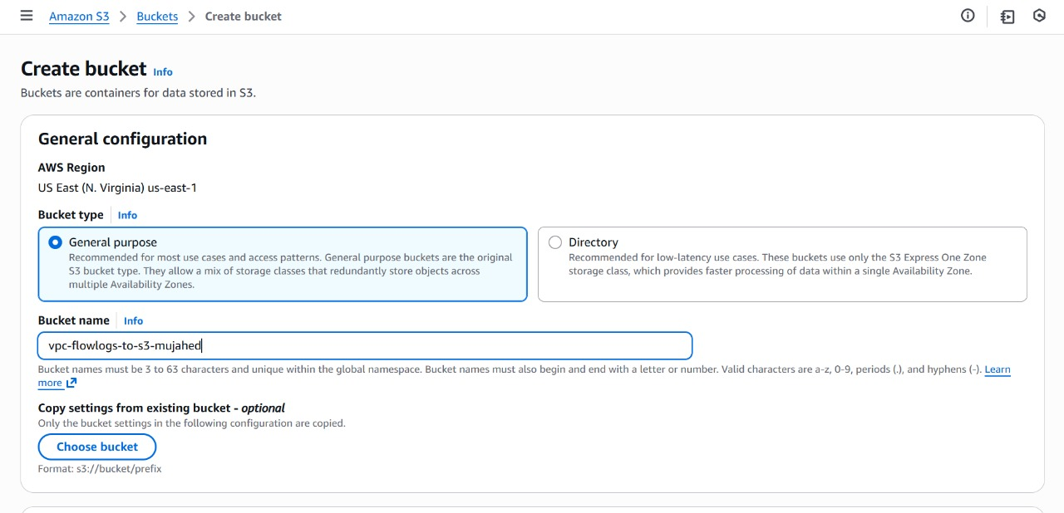

Steps: first we created an empty s3 bucket for flow logs.  
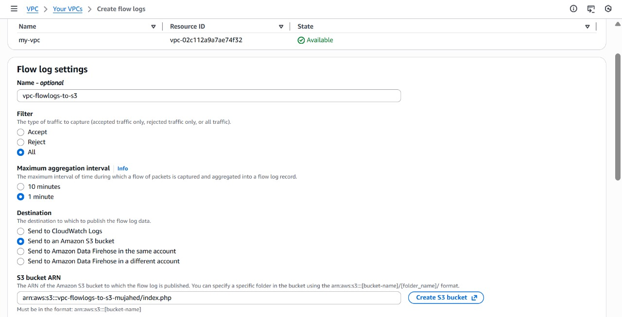

#then we go to vpc and select the vpc and click on flow logs and attach the s3 ARN link.  
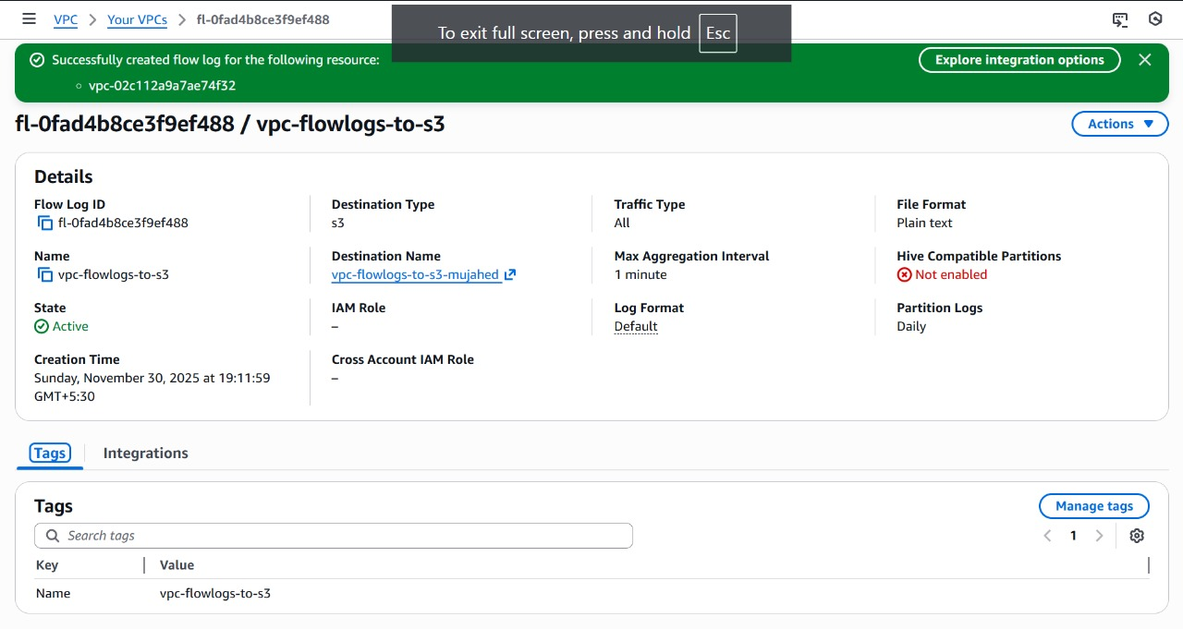  
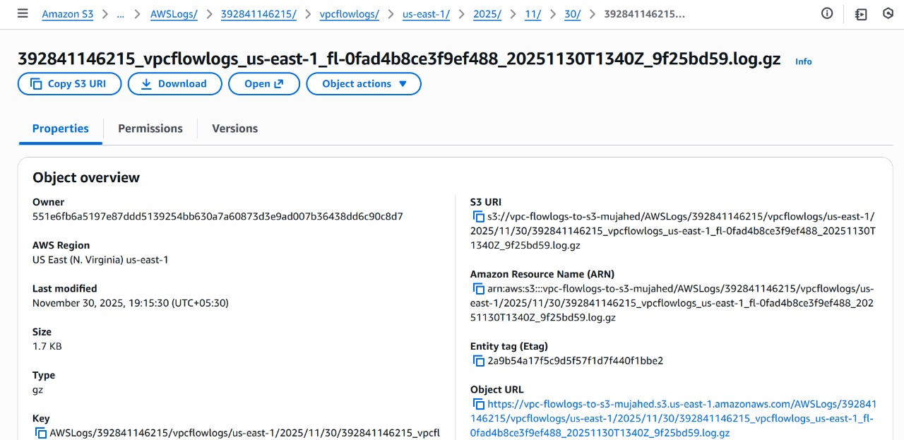  
click on logs and see te desire date logs by clicking on vpc logs .  
